AP350 Component Design – SDP OpsUI –
Version 0.1

Revision History

Date | Version | Description | Author
11/1/11 | 0.1 | Initial Draft | Ross Stockman

Approvals

Date (MMDDYY) | Role | Name of Approver | Version | Electronic Approval

External References
Topic | Reference | Link
Wire frames | Ap344 OpsUI wire frames
Page specification | Ap347 page specification

Table of Contents

1 Introduction 5
2 SDP Operations UI Overview 5
2.1 Name 5
2.2 Description 5
3 Design Overview 6
3.1 Research 6
3.2 Flow/Reflow 7
3.3 KeyCodeBank Dashboard 8
3.3.1 Load Keycodes 8
3.3.2 Keycode Load Management 10
3.3.3 Catalog Management 10
3.3.4 Reports 11
3.4 Audit Trail 11
3.5 Catalog Management 11
3.6 Preorder Management 11
3.7 ECC Console 11
4 Access Control 12
5 Configuration in sdp-config 12
5.1 Datasources 12
5.2 “Recent” Query Configuration 12
5.3 Deployment Environment 14
5.4 Environment Properties 14
5.5 Miscellanious Configuration 15
6 JSF 2.0 With ICEFaces2 15
6.1 Overview on ICEFaces2 15
6.2 Facelets 16
6.3 Reflow Xml Forms 16
6.4 Templates 17
6.5 Message Bundle 17
6.6 Validation.properties 17
7 Faces Config 17
8 OpsUI Java Classes 17
8.1 SdpTransactionDataBean.java and SdpTransactionDataXml.java 17
8.2 XXXHandler.java 18
8.3 XXXTabHandler.java 18
8.4 XXXDatatableHandler.java 19
8.5 XXXDBWrapper.java 19
8.6 SdpConfigProperties.java 19
8.7 Constants.java 19
8.8 NavigationStrings.java 19
8.9 XXXDownloadServlet.java 19
8.10 Request Manager.java 19
9 Views 19
9.1 Home 19
9.2 Catalog 20
9.3 Preorder 20
9.4 Vendor 21
9.5 Vendor Code 21
9.6 Keycode Bank 22
9.7 ECC Console 23
9.8 SDP Order Detail 24
9.9 SDP Order Search 24
9.10 SDP Request 24
9.11 Vendor Request 25
9.12 Vendor Provisioning Status 26
9.13 Error Screen 26
10 Error Handling 27
10.1 Stack Trace 27
10.2 Error Reference ID 27
11 Application Logging Using Apache Log4j 27
11.1 Changing Log Level Without Restart 27
12 Apache Axis2 Web Service Clients 28
12.1 Request Manager 28
13 SDP Database 28
13.1 Audit Trail Tables 29
13.1.1 AUD_SESSION 29
13.1.2 AUD_TRANSACTION 30
13.1.3 AUD_DATA_FIELDS 31
13.1.4 AUD_DATA_XML 31
13.1.5 REF_FIELD_TYPE 32
13.1.6 REF_AUD_ACTION 32
13.2 Dropdown list Configuration 33
13.2.1 UI_SCREEN 33
13.2.2 UI_SELECTITEM_COLLECTION 33
13.2.3 UI_SELECTITEM_OPTION 34
14 Glossary 34

Introduction

The SDP OpsUI component is a web based graphical user interface (GUI) tool that provides a view into the Service Delivery Platform (SDP) system for the processing of products and services through the in store retail, dotcom, and PC App. This includes programs such as Subscription Software (S2), Digital Sku, Black Tie Protection, Ask an Agent, and others. The SDP OpsUI also provides operational reflow functionality for all of these programs with exception to any transactions that require a real time activation, such as PC App and RTA (Universal Basket).

This AP350 Component Design document describes the OpsUI application, its place as it fits within existing application components, and the functionality which it exposes to the end user.

The OpsUI application’s purpose is to give the business operations team the ability to solve non IT related problems, such as improper execution of sales process at stores, without the assistance of the SDP technical production support team wherever possible. The SDP OpsUI application accomplishes this task by implementing its own custom logic in order to manipulate data in the SDP database and keycode bank database schemas and invoke web services exposed by SDP.

SDP Operations UI Overview
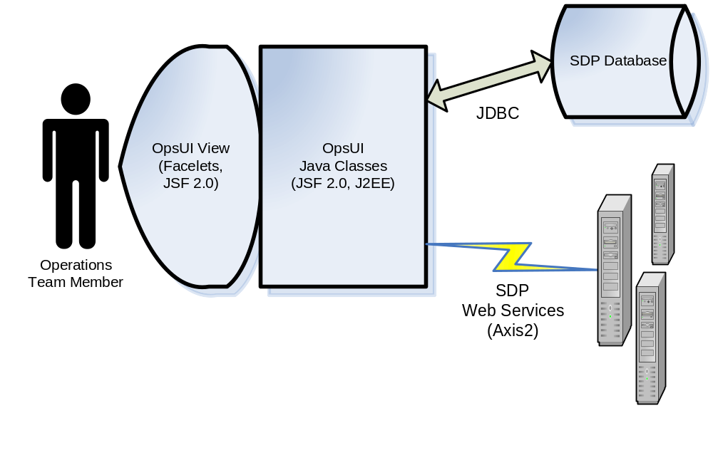
Figure 1 – OpsUI overview

Name

The application name is “SDP Operations UI” or “OpsUI” for short.

Description

The OpsUI component exposes research and reflow functionality to the operations user. It is a Model-View-Controller (MVC) pattern structured application which utilizes the Java Server Faces (JSF 2.0) framework for Java Enterprise Edition web applications.

OpsUI includes the following subcomponents:

- OpsUI View (Facelets)– JSF-centric view technology focusing on building JSF component trees.
- Form Handler Classes – Java class used to validate and perform actions on user submitted data such as from a form.
- Datatable Handler Classes – Java classes responsible for populating data tables and controlling sorting and pagination.
- Database Wrapper Classes – Java classes responsible for transforming, storing, and retrieving data from the database using JDBC and by calling stored proceedures.
- Download Servlets – servlets used by the application to generate an export file and attach to HTTP response allowing user to download the file.
- Apache Axis2 Web Service Clients – Custom Axis2 web service clients for interacting with SDP web services

Design Overview

The activities accomplishable from the OpsUI web application are divided primarily into three categories: transaction research, transaction reprocessing, and administration. A fourth category is also available only for IT support users for application monitoring and additional configuration.

Research

There are multiple ways in which a user can research transactional fallout from the OpsUI.
- Query the database using key transaction details
- View inbound transaction history (including the raw xml message)
- View vendor transaction history (including the raw xml message)
- View commsat transactio history
- View exception history (including the raw xml message and stack trace)
- View maintenance history via the Audit Trail.

Flow/Reflow
There are two encompassing types of flow that can be performed from within the OpsUI
- Reflow an existing transaction to SDP. This will take a BBYOrder xml document from the SDP_ORD_RQST_LOG table in the SDP database schema to generate a request message using the existing values in the BBYOrder. Using this BBYOrder as well as other details from this table, the OpsUI will submit the request message to the correct operation in the SDP fulfillment interface.
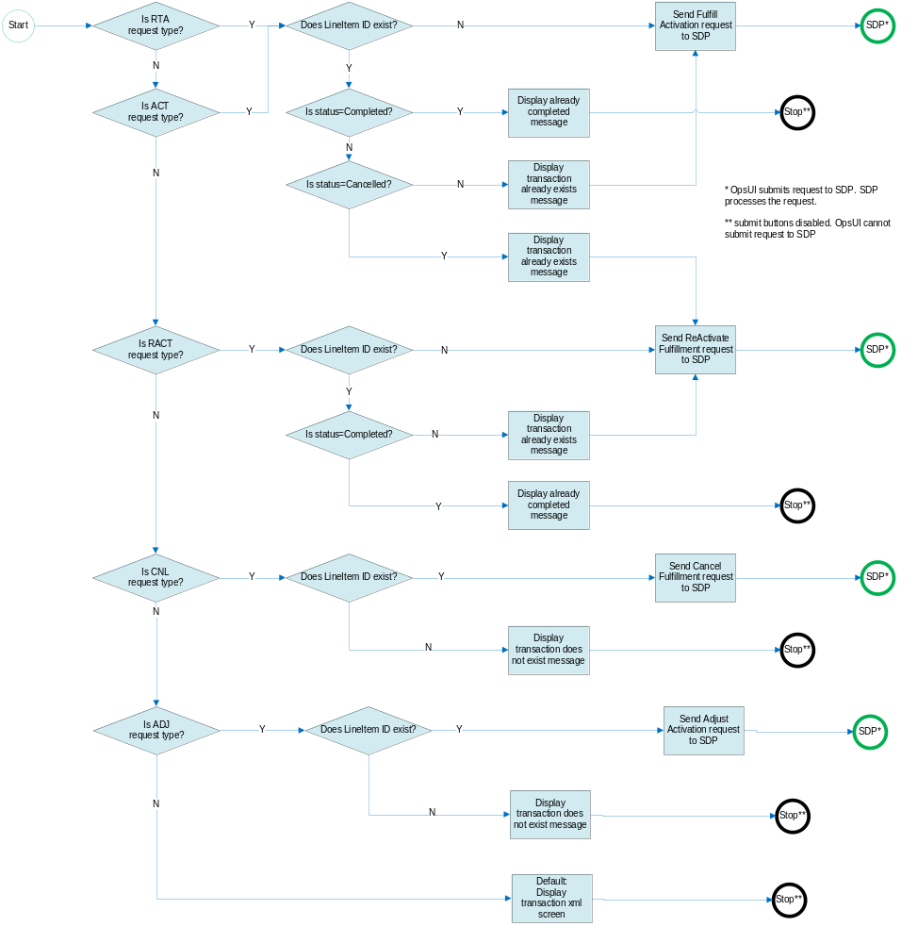
1 reflow transaction to SDP

- Submit an existing transaction to SDP from scratch. In this approach, the user will be presented with a blank form and will have to manually populate all of the fields with the appropriate data to be submitted to SDP for processing. As illustrated in the flow chart below, only activations and cancellations are allowed to be submitted from scratch. a ReActivate request will submitted automatically if it is determined that a transaction already exists with the given input and is currently in a cancelled status. Real Time Activation is not supported for reflow.
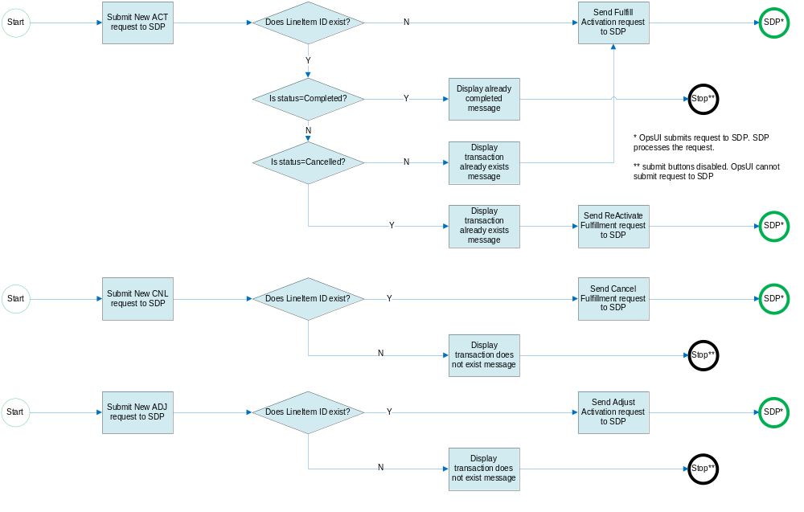
2 submit new request to SDP from scratch

- Flow/reflow to the commsat system. This allows user to update and resend a delivery email to the customer. This is available only for products where BBY supports sending emails through normal process flow. Note that in this flow the OpsUI will update the delivery email address value in the database if the commsat call was successful.
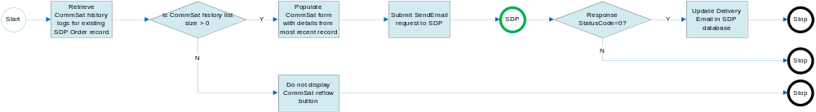

KeyCodeBank Dashboard

Load Keycodes
The primary function for the keycode bank UI is to load key codes into the keycode bank. This is achieved by uploading a specially formatted csv file containing at least one of the following details to identify the product:
- Merchandise SKU
- Non-Merchandise SKU
- Master Item ID
Any combination of these fields can be used as long as they all match up with a single Product ID.

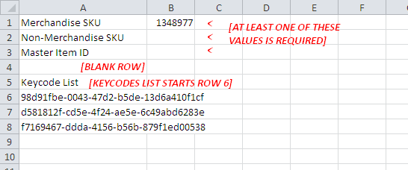
CSV template viewed from EXCEL

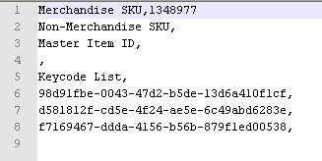
CSV template viewed from notepad

FileEntry Event Listener
The upload will commence when user clicks the “Validate” button. The upload process will write the uploaded file to the file system in a temp directory. The file is then validated by the following criteria:

- File extention must by .csv (not case sensitive).

- Input varialbes must be in the proper position and must pass character validation. See samples above.

  - Merchandise SKU value, if applicable, must be located on first line following exactly one leading comma.
  - Non-Merchanise SKU value, if applicable, must be located on second line following exactly one leading comma.
  - Master Item ID value, if applicable, must be located on third line following exactly one leading comma.

- Lines 4 and 5 must also pass through character validation, even though they are not used by the application. These lines can be used to store header information for readability or can be left blank.

- File must contain at least one keycode beginning at line 6. Each row should NOT contain a leading comma. See samples above.

If these conditions are not satisfied then an exception is thrown and the upload file is immediately deleted from the file system. If no exception is thrown then the process will check the database for any existing products matching the input variables, then continues to read each line containing a keycode. Each keycode will be checked for invalid characters and then stored in an ArrayList in memory. If any keycodes do not pass this validation they will be separated and stored in a separate list and displayed to the user. Once finished, the upload file is immediately deleted from the file system.

This diagram illustrates this process:
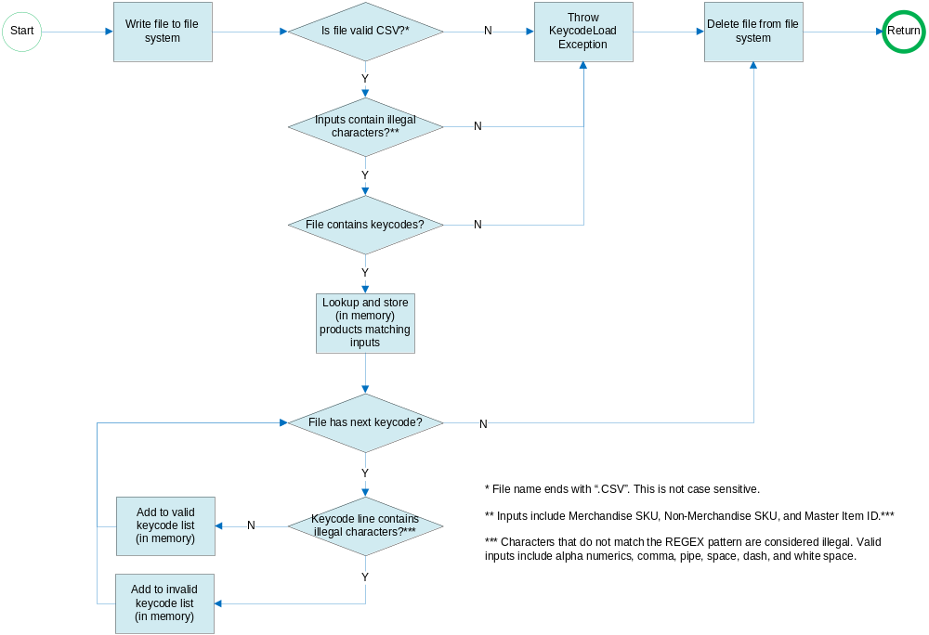
FileEntry Event Listener

Keycode File Validation
The actual validation process is not invoked until the FileEntry event listener returns. At this point the file is no longer present on the file system and validation continues with values stored in memory. If any keycodes were added to the invalid keycode list, or if more or less than one product ID was found during the file upload process above then the keycode upload will not proceed.
User must also provide these input details (Merchandise SKU, Non-Merchandise SKU, Master Item ID) on the UI page which will trigger the same product lookup and validation that a single Product ID exists matching the input varablles from the UI page. Upload will continue if and only if the Product ID retrieved from the input file validation matches the Product ID retrieved from the UI screen validation. This check will validate that the user is uploading the correct load file for the current product/vendor.

Keycode Load Management
OpsUI will allow users to lookup the history of keycode uploads from the batch management screens. Users can:

- Modify start and end dates associated with a given upload batch
- Delete entire upload batch - deleted keycodes will be moved to a new archive table for long term storage.

Catalog Management
OpsUI will give users new abilities to manage the keycode bank’s product catalog. Similar to the SDP catalog, users will be able to create and modify product entries and also export the entire catalog to a CSV file.The UI will ensure that no duplicate catalog entries are created. User can:

- Add new product to KCB catalog
- Modify existing product in KCB catalog
- Download export of entire KCB catalog in CSV format

Note: Vendor setup in the keycode bank catalog is handled by the Vendor Setup view in the OpsUI. This view will simultaneously manage both KCB_VENDOR table and SDP_VENDOR_CONFIG tables. So any vendor changes made on this screen will be applied to both tables.

Reports
The Keycode Bank Dashboard also includes various reports tracking key code usage and depletion estimates:
- Daily Summary – calculated daily
- Monthly Summary – month-to-date calculated daily
- Depletion Summary – shows calculated depletion estimate based on average number of sales in the last N number of days. This report is also exportable in CSV format. Also, by checking a box the depletion report can be filtered to display only products whose available keycode count has fallen below the configured depletion threshold.

Audit Trail
Captures the maintenance history of any user actions that involve manipulating data or viewing sensitive data in the OpsUI.
- View before and after comparisons of reflowed transactional data submitted from within the OpsUI
- View raw xml request and response details.
- Export audit log data to a csv file.
- Search logs by user id, activity, or by various transaction details like serial number or contract id.

Catalog Management
This section of the OpsUI will allow the business users to manage the SDP product catalog without any assistance from the IT Dev or Support teams. Users will be able to:
- Add new products to the catalog for processing instore retail transactions.
- Modify existing products
- Add new digital profiles for digital process digital sku transactions through dotcom channels
- Modify existing digital profiles
- Download an export of the entire catalog in CSV format
- Add new vendor configurations
- Edit existing vendor configurations
- Add new vendor error codes - these are for display throughout the OpsUI search and research screens.
- Modify existing vendor error codes.
This page must have validation that will prevent users from creating duplicate products or profiles in the catalog. Any changes made to the catalog will be logged in the audit trail.

Preorder Management
This section allows users to configure a street date indicating when a given sku can be processed in SDP. Users can:

- Create a new preorder schedule
- Edit an existing preorder schedule provided the street date has not passed.
- Delete preorder schedules that are in Released status

ECC Console
ECC console is a new application that will allow call center users to lookup customer transactions to verify their completion status and resend delivery emails. Users will lookup existing transactions in SDP by either BBY Order ID or by Four Part Key. If the resulting record(s) are in completed status user will be able to edit the email address if necessary and submit a request to SDP to resend the email to the customer (via Commsat).

Access Control

Access to the OpsUI is restricted to users who are members of the following roles. Users can gain access to these roles by submitting a BEAM request asking to be added to the associated LDAP group as follows:

Role Configuration | LDAP Group Associated to Role | Role Description
OpsUser | SOM_SUPP, SDP_OPS | General User. User cannot modify SDP configurations such as product catalog or load keycodes. User can reprocess transactions.
OpsAdmin | SOM_SUPP, SDP_OPS_ADMIN | Same as OpsUser. User can modify SDP configurations such as product catalog and can load keycodes. This role cannot modify vendor configurations. User can reprocess transactions.
Monitor | SOM_SUPP | IT Support User. Has full access modify SDP configurations, load keycodes, and reprocess transactions. Has access to view error stack trace details in addition to various technical screens.
ECCUser | SDP_ECC | User only has access to reprocess transactions from the ECC Console screen.

Configuration in sdp-config

Many of SDP OpsUI’s functionality is driven by configuration in the SDP’s configuration file sdp-config.properties. This file is located at:

/opt/appserver/bea/user_projects/domains/sdp-opsui/sdp-config/sdp-config.properties

If at any time this file is modified then a server restart will be required.

Datasources
The following properties in the configuration file identify the datasource jndi names used by the database connection manager classes com.accenture.bby.sdp.db.SomSdpDBWrapper.java and com.accenture.bby.sdp.db.KcbDBWrapper.java.

Property | Value at Initial Deployment | Purpose
sdp.jndi.jdbc.datasource.sdp | som.sdp.datasource | jndi name of sdp database schema
sdp.jndi.jdbc.datasource.kcb | som.kcb.datasource | jndi name of keycode bank database schema

“Recent” Query Configuration
In order to improve speed of the queries that retrieve the latest transactions the opsui will only look at records going back a configurable number of days to reduce the size of the resultset. For example, to retrieve the most recent sdp orders to display in the “Recent SDP Orders” page the opsui will only look back for records created in the last 10 days by default. As the database grows larger over time it may be necessary to reduce this number to look at a smaller result set, improving performance.

Property | Value at Initial Deployment | Purpose
sdp.OpsUI.maxDaysRecentTransactions | 10 | Maximum days to include in Recent SDP Orders result set
sdp.OpsUI.maxDaysRecentExceptions | 60 | Maximum days to include in Recent Exceptions result set
sdp.OpsUI.maxDaysRecentAuditLogs | 60 | Maximum days to include in Recent Audit Trail logs result set

Deployment Environment
In order for the OpsUI to make webservice calls to the SDP Service Bus layer, it will need to know, first, which environment it is deployed in. This is achieved by adding the following java option in the weblogic startup script:

Property (configured in weblogic startup script, not in sdp-config) | Purpose
sdp.OpsUI.deploymentEnvironment | Identifies the current deployment environment

For example (windows):
set JAVA_OPTIONS=%JAVA_OPTIONS% -Dsdp.OpsUI.deploymentEnvironment=devtest_a

For example (linux):
JAVA_OPTIONS="${JAVA_OPTIONS} -Dsdp.OpsUI.deploymentEnvironment=devtest_a"
export JAVA_OPTIONS

Environment Properties
These property values are environment specific. This is a list of all of the valid values for this property:

- devtest_a (Dev A environment)
- devtest_b (Dev B environment)
- prodtest_a (Prod Test A environment)
- prodtest_b (Prod Test B environment)
- pldr (PL/DR environment)
- prod (Production environment)

The values above should replace the [suffix] in the table below. These properties must be set in sdp-config for each of the environments listed above. For example sdp-config should contain these six lines
:
sdp.OpsUI.trustStoreLoc.devtest_a= [some value]
sdp.OpsUI.trustStoreLoc.devtest_b= [some value]
sdp.OpsUI.trustStoreLoc.prodtest_a= [some value]
sdp.OpsUI.trustStoreLoc.prodtest_b= [some value]
sdp.OpsUI.trustStoreLoc.pldr= [some value]
sdp.OpsUI.trustStoreLoc.prod= [some value]

See the environment spreadsheet for the expected values for these properties for each environment.
Property | Purpose
sdp.OpsUI.trustStoreLoc.[suffix] | Location of the trust store required for making secure webservice calls to the SDP SB layer.
sdp.OpsUI.sdp-sb.asyncFulfillmentServicesUrl.[suffix] | Url for the BS_FulfillmentServices web service
sdp.OpsUI.sdp-sb.bsSendEmail.[suffix] | Url for the BCS_SendEmail web service
sdp.OpsUI.sdp-sb.sendTpaUrl.[suffix] | Url for the BCS_VendorFulfillmentAdapter service.
sdp.OpsUI.sdp-sb.sendVendorUrl.[suffix] | Url for the INSERT NAME service.
sdp.sdpconsole.jmx.hostandport.[suffix] | Host and port of sdp-sb admin server. Used for queue monitoring from the OpsUI
sdp.sdpconsole.jmx.hostandport.so2.[suffix] | Host and port of so2 sb adminserver. Used for queue monitoring from the OpsUI. (this is currenly not used)
sdp.sdpconsole.jmx.hostandport.tpa.[suffix] | Host and port of tpa sb adminserver. Used for queue monitoring from the OpsUI. (this is currently not used)

Miscellanious Configuration

Property | Value at Initial Deployment | Purpose
sdp.OpsUI.maxQueryResults | 1000 | Maximum number of search results to return in the SDP Order query screen. If the result set is larger than the configured value then an error message is displayed to the user. The larger the result set, the slower the results screen could potentially load.
sdp.OpsUI.showStackTraceAllUsers | false | For security reasons it is necessary to not display any stack traces to general users in the event that an exception is thrown during the user’s session. It is possible to override this constraint by setting this property to true.  Note: Stack traces will always be printed in the log file.  Note: Users with access to the Monitor role will always be able to see stack traces.
sdp.OpsUI.reprocess  .fulfillment.sourceSystems | PBT,UB1,SDP_OPS_UI | Comma separated list of Source System IDs that can be reprocessed via the Fulfillment Services interface. OpsUI will disable the reprocess buttons if Source System ID value is not in this list (i.e., OMS)
sdp.sdpui.order.status.completed | 5 | Identifies status for orders in completed status. The ECC Console will only allow reprocessing if an SDP Order transaction is currently in completed status.
sdp.sdpui.preorder.status  .preorder | 9 | Identifies status for preorders in preorder status.
sdp.sdpui.preorder.status  .processing | 10 | Identifies status for preorders in processing status.
sdp.sdpui.preorder.status  .released | 11 | Identifies status for preorders in released status. The UI will only allow preorder records to be deleted when in this status.
sdp.sdpui.preorder.status  .deleted | 12 | Identifies status for preorders that user has marked as deleted. The UI will not display records with this status.

JSF 2.0 With ICEFaces2

Overview on ICEFaces2
ICEFaces2 is a Rich Internet Application development framework that extends the JSF 2.0 standard specification improving ease of development and providing rich components and enhanced Ajax support to be included in a JSF based web application.

Facelets
Starting with JSF 2.0, Facelets is the default view declaration language replacing the previous default JSP. Facelets are XML documents written as xhtml files and focus on building custom components, templates, and importing content from other xhtml pages.

The OpsUI will utilize Facelets to create separate components that can be imported into one or more views. For example, on the SDP Order Search screen there will be five separate components:
- Single Field Search
- Search By Transaction
- Search By Product
- Search By Customer Name
- Search Vendor Provisioning
Each of these components will be written as a separate xhtml file and imported together to form a single view. All xhtml Facelets are well formed XML documents, complete with valid namespaces, and must fit a master layout template.

The root element will always be a ui:composition tag and will identify the template file as shown in the following sample. The ui:define tag is used to define content to be inserted into the template file with a matching ui:insert tag. The ui:include tag is used to import content from another xhtml file.

<ui:composition template="/pages/templates/masterLayout.xhtml" xmlns:ui="http://java.sun.com/jsf/facelets" xmlns:h="http://java.sun.com/jsf/html" xmlns="http://www.w3.org/1999/xhtml">

<ui:define name="content">

<div id="top_content">
<ui:include src="/pages/catalog/catalog_search.xhtml" />
<ui:include src="/pages/catalog/catalog_view.xhtml" />
<ui:include src="/pages/catalog/catalog_edit.xhtml" />
</div>

<div id="datatable_panel">
<ui:include src="/pages/catalog/catalog_datatable.xhtml" />
</div>

</ui:define>
</ui:composition>

Reflow Xml Forms
SDP and Vendor reflow forms will be written as individual xml files and imported to the request facelet page as directed from the request page handler backing bean. Different criteria will determine the form being displayed. User will not need to select the specific form from a dropdown list in this release, rather user will provide either a product sku for SDP reprocessing or a vendor id for vendor reprocessing. The OpsUI will lookup the category which will determine which operations, if any, are available for reflow and user will then make a selection by clicking a button on screen. The xml forms themselves will be separated out by category and by operationFor example:

<div xmlns="http://www.w3.org/1999/xhtml" xmlns:h="http://java.sun.com/jsf/html" xmlns:f="http://java.sun.com/jsf/core" xmlns:ice="http://www.icesoft.com/icefaces/component">

<!-- TRANSACTION DATE -->
<h:outputLabel for="field_1" value="Transaction Date:" />
<ice:selectInputDate id=" field_1" value="#{sdpRequestBean.data.fpkTransactionDate}" />
<h:outputText value="*" rendered="true" styleClass="error" />
<h:outputText id=" field_1_ro" value="#{sdpRequestBean.data.fpkTransactionDate}" />
<h:message for=" field_1" styleClass="error" />

<!-- STORE # -->
<h:outputLabel for="field_2" value="Transaction Date:" />
<ice:selectInputDate id=" field_2" value="#{sdpRequestBean.data.fpkstoreId}" />
<h:outputText value="*" rendered="true" styleClass="error" />
<h:outputText id=" field_2_ro" value="#{sdpRequestBean.data.fpkstoreId}" />
<h:message for=" field_2" styleClass="error" />

</div>

Templates
All of the xhtml Facelets will import the same template, masterLayout.xhtml. The template is used to allow all pages to follow a similar pattern layout and common styling. It also allows each page to have the same header and title positions, even though the actual values of these titles may vary from page to page.

<!DOCTYPE html PUBLIC "-//W3C//DTD XHTML 1.0 Transitional//EN" "http://www.w3.org/TR/xhtml1/DTD/xhtml1-transitional.dtd"[]>
<html xmlns:ui="http://java.sun.com/jsf/facelets" xmlns:h="http://java.sun.com/jsf/html" xmlns="http://www.w3.org/1999/xhtml" xmlns:f="http://java.sun.com/jsf/core" xmlns:ice="http://www.icesoft.com/icefaces/component" xmlns:icecore="http://www.icefaces.org/icefaces/core" xmlns:ace="http://www.icefaces.org/icefaces/components">
<h:head>
<title>
<ui:insert name="windowTitle" />
</title>
<h:outputStylesheet library="css" name="stylesheet.css" />
<ice:outputStyle href="/xmlhttp/css/rime/rime.css" />
</h:head>
<h:body>
<div id="main">

<div id="content">
<ui:insert name="content" />
</div>
</div>
</h:body>
</html>
As shown in this example, the html, head, title, and body tags are all included in the template file. These tags could have existed in the imported xhtml files (with the ui:composition tag) as well but would have been ignored. In this template the ui:insert tag is used to insert the content from the matching ui:define tag from the ui:composition. It is worth noting that any changes made to this template will impact ALL screens in the OpsUI.

Message Bundle
The message bundle is a properties file that will be used by the xhtml files to import text content such as page titles and other global formatting, such as date formats, to be displayed on any screen in the UI. This file makes it possible to modify page titles without having to make changes to the xml content in the pages directly. The location of the file and the reference variable is defined in the faces-config.xml file.

Validation.properties
JSF provides various default validation messages that tend to be overly verbose. The workaround for this is to override the default validation messages in the validation.properties file with customized messages. Like the message bundle, this file is also defined in the faces-config.xml file. These validation messages are displayed in place of the h:message tags.

Faces Config
In this application, the faces-config.xml file will be used for registering message bundles, validation properties, and phase listener classes. In past iterations of JSF the faces-config was also used to declare managed beans and navigation rules but this is no longer necessary beginning with JSF 2.0. These declarations will instead be defined in the java files directly.

OpsUI Java Classes

The OpsUI Facelets and Java classes in this application will be built from scratch. In addition to view display, input validation and conversion these components implement all functionality (including database interaction and web service calls) that is required for the OpsUI application’s requirements and not leverageable from the SDP Technical Console.

This document highlights some of the key java classes:

SdpTransactionDataBean.java and SdpTransactionDataXml.java
The SdpTransactionDataBean class is the data object that represents an SDP Order in OpsUI and as such is the central data object of the application. This object’s role is to abstract the details of the sdp data model from the user to a single object rather than multiple objects. Essentially all data the user will ever need to process a transaction is available here in one common object.

This object can be created in two ways. It has a default no-arg constructor for use in a getter/setter population strategy. It has a constructor which takes an instance of itself for making clone instances of the same object. The SdpTransactionDataXml.java class is an extention of the SdpTransactionDataBean that adds an addition constructor that will take in BBYOrder XmlObject which will prepopulate all of the fields with details associated with any SDP ICDM transaction record.

Asside from the many getters and setters, the SdpTransactionDataXml class also has methods to generate various xml request messages that can be submitted to SDP for processing. This includes the following:
Method Name | Returned Object | Description
getIcdmBBYOrder | com.accenture.xml.sdp.bby.om.bbyOrder.  BBYOrderDocument | generates a BBYOrder xml object
getFulfillActivationRequest | com.bestbuy.schemas.sdp.fulfillactivation.  FulfillActivationRequestDocument | generates a FulfillActivateRequest xml object for PBT reflows
getCancelFulfillmentRequest | com.bestbuy.schemas.sdp.cancelfulfillment.  CancelFulfillmentRequestDocument | generates a CancelFulfillment xml object for PBT reflows
getReactivateFulfillmentRequest | com.bestbuy.schemas.sdp.reactivatefulfillment.  ReActivateFulfillmentRequestDocument | generates a ReActivateFulfillment xml object for PBT reflows
getAdjustActivationRequest | com.bestbuy.schemas.sdp.adjustactivation.  AdjustActivationRequestDocument | generates a AdjustActivation xml object for PBT reflows
getVendorActivateRequest | com.bestbuy.www.sdp.tpa.wsdl_tpa_services.  TpaProvisioningRequestDocument | generates a TPA activation request with a BBYOrder xml object included
getVendorCancelRequest | com.bestbuy.www.sdp.tpa.wsdl_tpa_services.  TpaProvisioningRequestDocument | generates a TPA cancellation request with a BBYOrder xml object included
getVendorRenewRequest | com.bestbuy.www.sdp.tpa.wsdl_tpa_services.  TpaProvisioningRequestDocument | generates a TPA renewal request with a BBYOrder xml object included
getVendorUpdateStatusRequest | com.bestbuy.www.sdp.tpa.wsdl_tpa_services.  TpaProvisioningRequestDocument | generates a TPA update status request with a BBYOrder xml object included
getCommsatRequest | com.bestbuy.sdp.bcs.csm.bcs_sendemail.  SendEmailServiceRequestDocument | generates SendEmail request with a BBYOrder xml object included

XXXHandler.java
Handler classes are managed beans responsible for populating, validating, and processing forms. Each view containing a form should have its own backing handler class. Handlers are also responsible for caturing appropriate logs for auditing users actions tracking any changes made or any sensitive data viewed. Handler classes are typically VIEW scoped, meaning once the view changes (i.e., user navigates to a different page) the Handler object will be garbage collected.

XXXTabHandler.java
Tab Handlers control basically the different sub views within a main view.

XXXDatatableHandler.java
Datatables displayed throughout the OpsUI will each be controlled by a Datatable Handler class. This class handles sorting, pagination, and any search operations that would affect the data displayed.

XXXDBWrapper.java
Database Wrapper classes provide a simple API that the OpsUI can use to insert, update, delete, and retrieve data from the database using JDBC. These classes will make use of Stored Procedures as much as possible rather than execute sql commands for better security and maintainability.

SdpConfigProperties.java
Reads properties from sdp-config.properties or from the database. Properties are read in one time and stored in cache. If any properties are updated then the application will require a restart to pull in the new properties.

Constants.java
Contsants class is a central location where all of the static variables should be stored that can be accessed by any class in the OpsUI. All variables here are declared public, static, and final.

NavigationStrings.java
NavigationStrings class is a central location storing strings used for navigation handling. Absolutely no navigation strings should be hard coded in any other XXXHandler class or any xhtml file. All variables here are declared public, static, and final.

XXXDownloadServlet.java
Servlets are used to allow user to download export files. The servlet will generate content for export and convert it to a byte array input stream. Using a buffered input/output stream the content will be attached to the HTTP response and presented to the user as a file download dialog box. If the download fails a 404 http error code will be returned from the server.

Request Manager.java
All web services that the OpsUI utilizes will be configured in the RequestManager class. The constructor of this singleton class will be responsible for setting the required system properties identifying the trust store location, which is necessary for SSL Handshakes to take place properly when sending requests.

The remaining methods in this class will be responsible for making the web service calls to the various interfaces in sdp using proxy services generated by Apache Axis2. The URLs of the webservices will be read from the sdp-config.

Method Name | Input Type | Return Type
getInstance() (singleton factory constructor) |  | Instance of com.accenture.sdp.ops.request.RequestManager
sendFulfillActivationRequestToSDP | com.bestbuy.schemas.sdp.fulfillactivation.FulfillActivationRequestDocument | com.bestbuy.schemas.sdp.fulfillactivation.FulfillActivationResponseDocument
sendCancelFulfillmentRequestToSDP | com.bestbuy.schemas.sdp.cancelfulfillment.CancelFulfillmentRequestDocument | com.bestbuy.schemas.sdp.cancelfulfillment.CancelFulfillmentResponseDocument
sendReActivationFulfillmentRequestToSDP | com.bestbuy.schemas.sdp.reactivatefulfillment.ReActivateFulfillmentRequestDocument | com.bestbuy.schemas.sdp.reactivatefulfillment.ReActivateFulfillmentResponseDocument
sendEmailRequest | com.bestbuy.sdp.bcs.csm.bcs_sendemail.SendEmailServiceRequestDocument | com.bestbuy.sdp.bcs.csm.bcs_sendemail.SendEmailServiceResponseDocument
sendDirectToVendorRequest

Views
This section will list all of the views, or pages, throughout the OpsUI. For more detailed walkthrough please reference the AP344 Wireframes document.

Home
Description: Home page is the default landing page for all users and roles (with exception to users who only have access to ECCUser role) after logging in. It is the central hub linking to all other screens around the OpsUI.
View: Home
Managed Beans: | HomePageHandler homePageHandler | Scope: ViewScoped | Handles the home page form
Input Data: | none
Output Data: | none
Facelets: | home.xhtml |  | default page - contains all form content

Catalog
Description: Catalog page is where admin users will configure the SDP internal product catalog. Users will be able to create and modify product skus configured for instore retail transactions as well as create and modify digital profiles for dotcom and digital sku transactions. Only users with access to the OpsAdmin role will be able to save changes to the catalog, all other users will have read only access.

View: Catalog
Managed Beans: | CatalogHandler  catalogHandler | Scope: ViewScoped |  | Handles the main catalog form
Managed Beans: | CatalogDatatable  catalogDatatable | Scope: ViewScoped |  | Handles the datatable and search capabilities
Managed Beans: | CatalogTabbedPaneHandler  catalogTabbedPaneHandler | Scope: ViewScoped |  | Handles the page flow in the catalog view
Input Data: | none
Output Data: | none
Facelets: | catalog_datatable.xhtml |  | renders the catalog datatable
Facelets: | catalog_edit_attributes.xhtml |  | renders the editable Boolean attributes (right side of the editable form)
Facelets: | catalog_edit_detail.xhtml |  | renders the editable text fields (left side of the editable form)
Facelets: | catalog_edit.xhtml |  | couples the layout of the editable catalog form
Facelets: | catalog_search.xhtml |  | renders the search form
Facelets: | catalog_view_attributes.xhtml |  | renders the readonly Boolean attributes (right side of read only form)
Facelets: | catalog_view_detail.xhtml |  | renders the readonly text fields (left side of read only form)
Facelets: | catalog_view.xhtml |  | couples the layout of the readonly catalog form
Facelets: | catalog.xhtml |  | default layout page – controls page titles

Preorder
Description: Displays the preorder streetdate schedule for all catalog products that are in preorder hold status. Users with OpsAdmin access will be able to create new preorder schedules and modify existing preorder schedules. Once a preorder line item has reached its street date the schedule can no longer be edited. User will be able to remove the preorder schedule once the status of the schedule is ‘Released’, status 11.

View: Preorder
Managed Beans: | PreorderHandler  preorderHandler | Scope: ViewScoped |  | Handles the main preorder form
Managed Beans: | PreorderDatatable  preorderDatatable | Scope: ViewScoped |  | Handles the datatable and search capabilities
Managed Beans: | PreorderTabbedPaneHandler  preorderTabbedPaneHandler | Scope: ViewScoped |  | Handles the page flow in the preorder view
Input Data: | none
Output Data: | none
Facelets: | preorder_createSchedule.xhtml |  | renders the create schedule form
Facelets: | preorder_datatable.xhtml |  | renders the preorder schedule data table
Facelets: | preorder_detail.xhtml |  | renders the read only details of the preorder record
Facelets: | preorder_editSchedule.xhtml |  | renders the update schedule form
Facelets: | preorder_history.xhtml |  | renders the update history of the preorder record
Facelets: | preorder_productLookup.xhtml |  | renders the product lookup form used for looking up the product sku being set up with a preorder schedule
Facelets: | preorder_removeSchedule.xhtml |  | renders the delete schedule form
Facelets: | preorder_search.xhtml |  | renders the preorder schedule search form
Facelets: | preorder.xhtml |  | default layout page – controls page titles

Vendor
Description: Vendor page is where IT admin users can configure new vendors and update existing vendors in both the SDP catalog and in the Keycode Bank catalog. Only users with access to the Monitor role will be able to make changes to vendor configurations. All other users will have read only access to this view.

View: Vendor
Managed Beans: | VendorHandler  vendorHandler | Scope: ViewScoped |  | Handles the main vendor form
Managed Beans: | VendorDatatable  vendorDatatable | Scope: ViewScoped |  | Handles the datatable and search capabilities
Managed Beans: | VendorTabbedPaneHandler  vendorTabbedPaneHandler | Scope: ViewScoped |  | Handles the page flow in the vendor view
Input Data: | none
Output Data: | none
Facelets: | vendor_datatable.xhtml |  | renders the vendor datatable
Facelets: | vendor_edit.xhtml |  | renders the editable create and update vendor form
Facelets: | vendor_search.xhtml |  | renders the vendor search form (currently only has a ‘Create New Vendor’ button).
Facelets: | vendor.xhtml |  | default layout page – controls page titles

Vendor Code
Description: Vendor code page is where IT admin users can configure new vendor codes and update existing vendor codes in the SDP catalog. These codes are used to display descriptions of vendor response codes and are populated in various dropdown lists in the OpsUI and are also visible in vendor reports. Only users with access to the Monitor role will be able to make changes to vendor code configurations. All other users will have read only access to this view.

View: Vendor Code
Managed Beans: | VendorCodeHandler  vendorCodeHandler | Scope: ViewScoped |  | Handles the main vendor code form
Managed Beans: | VendorCodeDatatable  vendorCodeDatatable | Scope: ViewScoped |  | Handles the datatable and search capabilities
Managed Beans: | VendorCodeTabbedPaneHandler  vendorCodeTabbedPaneHandler | Scope: ViewScoped |  | Handles the page flow in the vendor code view
Input Data: | Vendor ID. VendorCodeHandler will first check for context parameter then for session parameter for variable named “vendorId”. If both return null or if the vendorId value is not valid then an excedption is thrown
Output Data: | none
Facelets: | vendor_code_datatable.xhtml |  | renders the vendor code list datatable
Facelets: | vendor_code_edit.xhtml |  | renders the editable create and update vendor code form
Facelets: | vendor_code_default.xhtml |  | currently only a place holder as there is no search capability for vendor codes
Facelets: | vendor_code.xhtml |  | default layout page – controls page titles

Keycode Bank
Description: KeycodeBank view is broken up into four parts: loading keycodes, managing loaded keycode batches, managing the keycode bank catalog, and reporting. Only users with OpsAdmin access will be able to modify the kcb catalog. Only users with OpsAdmin access will be able to load keycodes or modify loaded keycode batches (i.e., modifying the valid date range or deleting batches).

View: Keycode Bank
Managed Beans: | KeycodeBankLoadDatatable  keycodeBankLoadDatatable |  | Scope: ViewScoped | Handles the invalid keycode data table
Managed Beans: | KeycodeBankLoadHandler  keycodeBankLoadHandler |  | Scope: ViewScoped | Handles the main keycode load form
Managed Beans: | KeycodeBankLoadTabbedPaneHandler  keycodeBankLoadTabbedPaneHandler |  | Scope: ViewScoped | Handles the page flow in the keycode load view
Managed Beans: | KeycodeBankManageLoadDatatable  keycodeBankManageLoadDatatable |  | Scope: ViewScoped | Handles the keycode load batch data table
Managed Beans: | KeycodeBankManageLoadHandler  keycodeBankManageLoadHandler |  | Scope: ViewScoped | Handles the main keycode batch update form
Managed Beans: | KeycodeBankManageLoadTabbedPaneHandler  keycodeBankManageLoadTabbedPaneHandler |  | Scope: ViewScoped | Handles the page flow in the manage keycode batch view
Managed Beans: | KeycodeBankProductCatalogDatatable  keycodeBankProductCatalogDatatable |  | Scope: ViewScoped | Handles the product catalog data table
Managed Beans: | KeycodeBankProductCatalogHandler  keycodeBankProductCatalogHandler |  | Scope: ViewScoped | Handles the main create and update product form
Managed Beans: | KeycodeBankProductCatalogTabbedPaneHandler  keycodeBankProductCatalogTabbedPaneHandler |  | Scope: ViewScoped | Handles the page flow in the product catalog view
Managed Beans: | KeycodeBankReportDatatable  keycodeBankReportDatatable |  | Scope: ViewScoped | Handles the reporting data table
Managed Beans: | KeycodeBankReportHandler  keycodeBankReportHandler |  | Scope: ViewScoped | Handles the main reporting form
Managed Beans: | KeycodeBankReportTabbedPaneHandler  keycodeBankReportTabbedPaneHandler |  | Scope: ViewScoped | Handles the page flow in the reporting view
Input Data: | none
Output Data: | none
Facelets: | keycodeBank_catalog_datatable.xhtml | renders the keycode bank catalog datatable
Facelets: | keycodeBank_catalog_edit.xhtml | renders the create and upldate product form
Facelets: | keycodeBank_catalog_search.xhtml | renders product search form
Facelets: | keycodeBank_catalog.html | couples the keycode bank catalog layout
Facelets: | keycodeBank_dashboard_daily_report.xhtml | renders daily report
Facelets: | keycodeBank_dashboard_depletion_report.xhtml | renders depletion report
Facelets: | keycodeBank_dashboard_monthly_report.xhtml | renders monthly report
Facelets: | keycodeBank_dashboard_ report.xhtml | couples the keycode bank report layout
Facelets: | keycodeBank_dashboard.xhtml | couples the keycode bank catalog layout
Facelets: | keycodeBank_load_complete.xhtml | renders keycode load status form
Facelets: | keycodeBank_load_datatable.xhtml | renders the invalid keycode datatable
Facelets: | keycodeBank_load_form.xhtml | renders load keycodes form
Facelets: | keycodeBank_load_validate.xhtml | renders load validation form
Facelets: | keycodeBank_load.xhtml | couples the keycode bank catalog layout
Facelets: | keycodeBank_manageLoad_datatable.xhtml | renders the keycode batch management datatable
Facelets: | keycodeBank_manageLoad_edit.xhtml | renders edit batch form
Facelets: | keycodeBank_manageLoad_search.xhtml | renders batch search form
Facelets: | keycodeBank_manageLoad.xhtml | couples the keycode bank catalog layout
Facelets: | keycodeBank.xhtml | default page – controls page titles and couples keycode bank layout

ECC Console
Description: The ECC Console page provides capability to the call centers to lookup completed orders in SDP and resend the delivery email to customers. Users will be able to change the delivery email before submitting. Users must have access to the ECCUser role to perform these actions. All actions performed in ECC Console view will be captured by the Audit Trail.

View: ECC Console
Managed Beans: | ECCUIHandler  eccuiHandler | Scope: ViewScoped |  | Handles the form for submission and audit log capture
Managed Beans: | ECCUIDatatable  eccuiDatatable | Scope: ViewScoped |  | Handles the datatable and search capabilities
Input Data: | none
Output Data: | none
Facelets: | eccui_datatable.xhtml |  | renders the record search results datatable
Facelets: | eccui_search.xhtml |  | renders the record search form
Facelets: | eccui.xhtml |  | default page – controls page titles and couples eccui page layout

SDP Order Detail
Description: SDP Order Detail view displays the full detail and complete history of an sdp order. This includes current order details and status, transaction history, vendor history, commsat history, exception history, etc… It is also the central location for reprocessing existing transactions to various points in SDP.

View: SDP Order Detail
Managed Beans: | SdpOrderDetailHandler  sdpOrderDetailHandler | Scope: ViewScoped |  | Handles the form sdp order details and handles all of the datatables in this view
Input Data: | SDP Order ID. SdpOrderDetailHandler will first check for context parameter then for session parameter for variable named “sdpOrderId”. If both return null or if the vendorId value is not valid then an excedption is thrown
Output Data: | none
Facelets: | sdpOrderDetail_commsatHistory.xhtml |  | renders the commsat history data table
Facelets: | sdpOrderDetail_exceptionHistory.xhtml |  | renders the exception history data table (hidden by default)
Facelets: | sdpOrderDetail_orderDetail.xhtml |  | renders the order details (left side panel)
Facelets: | sdpOrderDetail_statusHistory.xhtml |  | renders the status history data table (hidden by default)
Facelets: | sdpOrderDetail_transactionHistory.xhtml |  | renders the transaction history data table
Facelets: | sdporderDetail_vendorRequestHistory.xhtml |  | renders the vendor request history data table
Facelets: | sdpOrderDetail.xhtml |  | default page – controls page titles and couples page layout

SDP Order Search
TBD

SDP Request
Description: SDP Request view handles all reflow requests to the SDP BS_FulfillmentServices interface. If reflowing transactions from scratch, users must provide a primary sku. Then, after selecting an operation based on the category of the primary sku, the user will be able to fill out a blank reflow form and submit the request for reprocessing. See the Flow/Reflow section for detailed logic on reflow.

View: SDP Request
Managed Beans: | SdpRequestHandler  sdpRequestHandler | Scope: ViewScoped |  | Handles the sdp request form and page flow
Input Data: | Request ID. SdpRequestHandler will first check for context parameter then for session parameter for variable named “requestId”. If both return null then a blank form will be displayed. If request ID is invalid then an exception will be thrown.
Output Data: | none
Facelets: | sdpRequest_form.xhtml |  | couples all of the various request forms
Facelets: | sdpRequest_operation.hxtml |  | renders form for selecting operation
Facelets: | sdpRequest_submitted.xhtml |  | renders results after submitting request forms
Facelets: | sdpRequest.xhtml |  | default page – controls page titles and couples page layout
Facelets: | sdpRequest_s2_fulfillActivation.xhtml |  | s2 activation form
Facelets: | sdpRequest_psa_fulfillActivation.xhtml |  | psa activation form
Facelets: | sdpRequest_tech_suport_fulfillActivation.xhtml |  | tech support activation form
Facelets: | sdpRequest_digital_fulfillActivation.xhtml |  | digital activation form
Facelets: | sdpRequest_s2_cancelFulfillment.xhtml |  | s2 cancellation form
Facelets: | sdpRequest_psa_ cancelFulfillment.xhtml |  | psa cancellation form
Facelets: | sdpRequest_tech_suport_ cancelFulfillment.xhtml |  | tech support cancellation form
Facelets: | sdpRequest_digital_ cancelFulfillment.xhtml |  | digital cancellation form
Facelets: | sdpRequest_s2_reactivateFulfillment.xhtml |  | s2 reactivation form
Facelets: | sdpRequest_psa_ reactivateFulfillment.xhtml |  | psa reactivation form
Facelets: | sdpRequest_tech_suport_ reactivateFulfillment.xhtml |  | tech support reactivation form
Facelets: | sdpRequest_digital_ reactivateFulfillment.xhtml |  | digital reactivation form
Facelets: | sdpRequest_s2_adjustActivation.xhtml |  | s2 adjustment form
Facelets: | sdpRequest_psa_adjustActivation.xhtml |  | psa adjustment form
Facelets: | sdpRequest_tech_suport_adjustActivation.xhtml |  | tech support adjustment form
Facelets: | sdpRequest_digital_adjustActivation.xhtml |  | digital adjustment form

Vendor Request
Description: Vendor Request view handles all reflow requests to the SDP BCS_VendorAdapter interface. If reflowing transactions from scratch, users must provide a primary sku. Then, after selecting an operation based on the category of the primary sku, the user will be able to fill out a blank reflow form and submit the request for reprocessing.

View: Vendor Request
Managed Beans: | VendorRequestHandler  vendorRequestHandler | Scope: ViewScoped |  | Handles the vendor request form and page flow
Input Data: | Request ID. VendorRequestHandler will first check for context parameter then for session parameter for variable named “requestId”. If both return null then a blank form will be displayed. If request ID is invalid then an exception will be thrown.
Output Data: | none
Facelets: | vendorRequest_form.xhtml |  | couples all of the various request forms
Facelets: | vendorRequest_operation.hxtml |  | renders form for selecting operation
Facelets: | vendorRequest_submitted.xhtml |  | renders results after submitting request forms
Facelets: | vendorRequest.xhtml |  | default page – controls page titles and couples page layout
Facelets: | vendorRequest_s2_act.xhtml |  | s2 activation form
Facelets: | vendorRequest_psa_act.xhtml |  | psa activation form
Facelets: | vendorRequest_s2_cnl.xhtml |  | s2 cancellation form
Facelets: | vendorRequest_psa_ cnl.xhtml |  | psa cancellation form
Facelets: | vendorRequest_s2_rnw.xhtml |  | s2 renewal form
Facelets: | vendorRequest_s2_upd.xhtml |  | s2 modify status form

Vendor Provisioning Status
Description: Vendor ProvisioningStatus view displays the full detail and complete request and response history of the external target system, including third party vendors, Commsat, and CA.

View: Vendor Provisioning Status
Managed Beans: | VendorProvisioningStatusHandler  vendorProvisioningStatusHandler | Scope: ViewScoped |  | Handles the vendor provisioning status form and page flow
Input Data: | VPS ID. VendorRequestHandler will first check for context parameter then for session parameter for variable named “vpsId”. If both return null or invalid then an exception will be thrown.
Output Data: | none
Facelets: | vendorProvisioningStatus_datatable.xhtml |  | renders the request and response history data table
Facelets: | vendorProvisioningStatus_orderDetail.xhtml |  | renders the vps transaction details table
Facelets: | vendorProvisioningStatus.xhtml |  | default page – controls page titles and couples page layout

Error Screen
Description: Error Screen displays details of any exceptions caught by the SDP OpsUI and handled via the ExceptionHandler. See Error Handling for details on OpsUI errors.

View: Error
Managed Beans: | ExceptionHandler  exceptionHandler | Scope: SessionScoped |  | Handles the exception details form. These are exceptions caught and handled by the OpsUI application.
Managed Beans: | ExceptionDefaultHandler  exceptionDefaultHandler | Scope: RequestScoped |  | Handles the error details form. These are runtime or servlet exceptions not handled by the OpsUI application.
Input Data: | none
Output Data: | none
Facelets: | generalError.xhtml |  | renders unhandled error details
Facelets: | generalException.xhtml |  | renders handled exception details

Error Handling
If an error occurs in the OpsUI during a users session, a customized technical error screen is displayed showing details of the error and/or a reference id allowing users to search for the error details in the application log files.

Stack Trace
In compliance with secure code reviews, the SDP OpsUI must never display exception stack traces to common users of the SDP OpsUI if an exception is thrown. For example, if the OpsUI is unable to connect to the database, the resulting SQLException must not be displayed to the user as it might contain sensitive details about the database and or the SDP back end system. Only users with acess to the Monitor user role will be able to view exception stack traces on the OpsUI screens. The stack trace will always be written to the application output log files regardless of the users role access.

Error Reference ID
Error Reference ID is a 36 character unique string (GUID) that will display on the technical error screens to reference the corresponding error stack trace that is written to the application output log file. Since stack trace details cannot be displayed for common users this is essentially the only way for the SDP Support team to investigate any issues experienced by these users. For example, a user might attempt to access the OpsUI but instead keeps seeing a general error message and the following reference id:

- Reference Id: 2646a3ad-0225-4aa0-894f-6aa4fbd61bb3

A user with Monitor access can use this reference ID to locate the corresponding error stack trace from the application output logs to investigate the root cause of the error in more detail. In this example the following stack trace might be printed in the log file indicating that user a123456 attempted to access the application but was denied access and the server returned code 403 Forbidden:

[
Reference Id: 2646a3ad-0225-4aa0-894f-6aa4fbd61bb3
ErrorCode: 403
URL: /SDPOpsUI/OpsUI/home.jsf
Exception: class javax.security.auth.login.FailedLoginException
Message: [Security Authentication Failed: User a123456 denied:
]

Application Logging Using Apache Log4j

OpsUI will utilize Apache Log4j to handle application logging. The log4j.properties configuration file will be placed at:

/opt/appserver/bea/user_projects/domains/sdp-opsui/sdp-config/log4j/log4j-opsui.properties

If at any time this file is modified then a server restart will be required.

Description | Detail
Appender type | Rolling File Appender
Log file location | /opt/logs/sdp-opsui/applog-<SERVER_NAME>.log
Max log file size | 50 MB
Backup files stored in archive | 6
Conversion pattern | ### [%d] | %-5p | %C | %M | %F:%L | %m%n
Default level | INFO

Sample format:
### [2011-11-17 10:01:21,674] | INFO | com.accenture.bby.sdp.web.servlet.Log4jInitServlet | init | Log4jInitServlet.java:39 | Log4j initialized.

Changing Log Level Without Restart
There are two ways to change the log level in production without requiring a server restart, both involve accessing the Log4jInitServlet and passing in certain parameters.

- To change the log level directly enter the servlet URL in the browser and pass in the following parameter: logLevel=DEBUG.
  - Valid values are DEBUG, INFO, WARN, ERROR, FATAL
  - Example: http://opsui-sdp/SDPUI/logging?logLevel=DEBUG
- To reload the log4j.properties file enter the servlet URL in the browser and pass in the following parameter: reloadPropertiesFile=someValue
  - As long as the parameter value is not blank, any value will work
  - Example: http://opsui-sdp/SDPUI/logging?reloadPropertiesFile=OK

In both cases a new screen will display the status status.

Apache Axis2 Web Service Clients

The web service clients for BCS_SendEmail and BS_FulfillmentServices web services will be generated by Apache Axis2’s wsdl2java technology. These clients expose a java interface to the necessary web service hosts to the OpsUI application and are the conduits for web service based reflow in OpsUI.

A tool that will create these proxy services will be included with the sdp-opsui project and will require Apache Ant to run. This tool will require a wsdl file to generate a jar file containing the stub classes that make up the proxy service. The OpsUI will pass the request message and the url (See Environment Properties).

The trust store location must also be set as a system property in order to hit the secure webservices in SDP

Request Manager
(see RequestManager class)

SDP Database

This document will not go into detail about all of the SDP database schemas. This section will focus mainly on the database tables in the SDP schema that are created specifically for the OpsUI.

Audit Trail Tables

These will be used to capture user actions in the SDP OpsUI and potentially other web applications. These tables allow users to track changes made when user reflows xml messages throughout the SDP application. It can also be used to track who is viewing customer records. In the OpsUI, a new section is being added to allow users to perform various searches to pull up and review these audit logs.
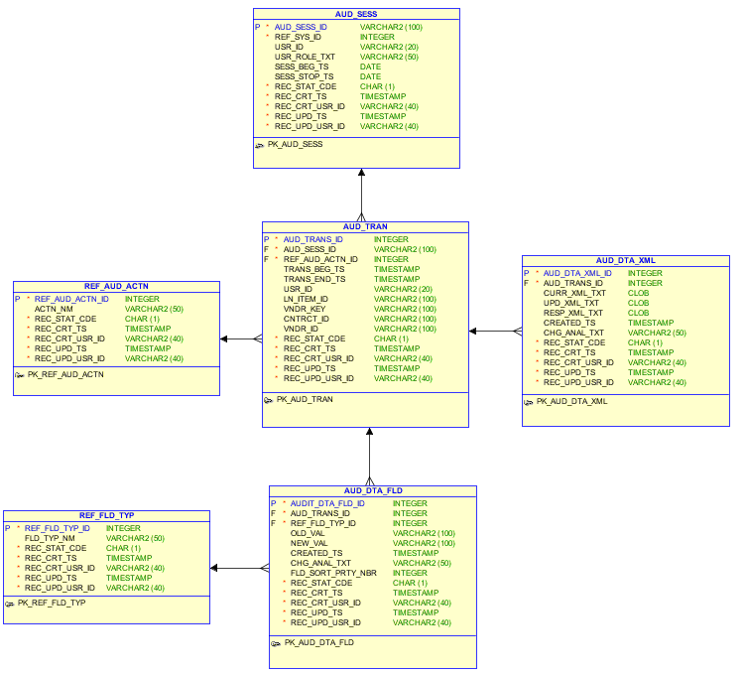

AUD_SESSION

Table: AUD_SESS
Column | Type | Required | Description
AUD_SESS_ID | INT | Y | Primary Key.
USR_ID | VARCHAR2  (20) | Y | User Identity (AID). User logs in with LDAP credentials (e.g., a123456)
USR_ROLE_TXT | VARCHAR2  (50) | N | If needed could store user’s role or comma separated list of roles. Default=null
SESS_BEG_TS | Date | N | Timestamp when user logged in. Default=null
SESS_STOP_TS | Date | N | Timestamp when session is closed/expires (need to determine if this is useful for Audit Trail). Default=null
REF_SYS_ID | INT | Y | Foreign Key: REF_SYSTEM.Sys_Id.  References which application this session belongs to
REC_STAT_CDE | CHAR(1) | Y | Standard Column – status code
REC_CRT_TS | TIMESTAMP | Y | Standard Column – created date
REC_CRT_USR_ID | VARCHAR2  (40) | Y | Standard Column – user who created the record
REC_UPD_TS | TIMESTAMP | Y | Standard Column – updated date
REC_UPD_USR_ID | VARCHAR2  (40) | Y | Standard Column – user who updated the record

AUD_TRANSACTION

Table: AUD_TRAN
Column | Type | Required | Description
AUD_TRANS_ID | INT | Y | Primary Key.
TRANS_BEG_TS | Date | Y | Timestamp when transaction occurred
TRANS_END_TS | Date | N | Timestamp when transaction completed. May be useful to track duration or performance of certain operations. Default=null
AUD_SESS_ID | INT | Y | Foreign Key: AUD_SESSION.Session_Id  References which user session the transaction belongs to
REF_AUD_ACTN_ID | INT | Y | Foreign Key: REF_AUD_ACTION.Action_Id  References what type of action was performed
USR_ID | VARCHAR2  (20) | N | Search field – search by user who initiated the transaction
LN_ITEM_ID | VARCHAR2  (100) | N | Search field – search by line item id
VNDR_KEY | VARCHAR2  (100) | N | Search field – search by vendor key (serial number)
CNTRCT_ID | VARCHAR2  (100) | N | Search field – search by contract id
VNDR_ID | VARCHAR2  (100) | N | Search field – search by vendor id
PRM_SKU_ID | VARCHAR2  (100) | N | Search field – search by primary sku
REC_STAT_CDE | CHAR(1) | Y | Standard Column – status code
REC_CRT_TS | TIMESTAMP | Y | Standard Column – created date
REC_CRT_USR_ID | VARCHAR2  (40) | Y | Standard Column – user who created the record
REC_UPD_TS | TIMESTAMP | Y | Standard Column – updated date
REC_UPD_USR_ID | VARCHAR2  (40) | Y | Standard Column – user who updated the record

AUD_DATA_FIELDS

Table: AUD_DTA_FLD
Column | Type | Required | Description
AUDIT_DTA_FLD_ID | INT | Y | Primary Key.
OLD_VAL | VARCHAR2  (250) | N | Original value of form being modified. If this is the first time this form is being filled out than this value should be null. Default=null
NEW_VAL | VARCHAR2  (250) | N | New value of form being modified. If this value is not populated in the form then this value should be null. Default=null
CREATED_TS | DATE | N | Timestamp when field was created. Sysdate in oracle. Default=null
CHG_ANAL_TXT | VARCHAR2  (50) | N | Indicates changes that occurred for this particualer field. If no changes occurred then this can be null. Default=null
FLD_SORT_PRTY_NBR | INT | Y | Allows for customized sort order when selecting all fields for a given transaction. Default=0
AUD_TRANS_ID | INT | Y | Foreign Key: AUD_TRANSACT.Session_Transact_Id.  References transaction that this field is associated with
REF_FLD_TYP_ID | INT | Y | Foreign Key: REF_FIELD_TYPE.  References field type
REC_STAT_CDE | CHAR(1) | Y | Standard Column – status code
REC_CRT_TS | TIMESTAMP | Y | Standard Column – created date
REC_CRT_USR_ID | VARCHAR2  (40) | Y | Standard Column – user who created the record
REC_UPD_TS | TIMESTAMP | Y | Standard Column – updated date
REC_UPD_USR_ID | VARCHAR2  (40) | Y | Standard Column – user who updated the record

AUD_DATA_XML

Table: AUD_DTA_XML
Column | Type | Required | Description
AUD_DTA_XML_ID | INT | Y | Primary Key.
CURR_XML_TXT | CLOB | N | Xml currently stored in database before modification. If this is the first time this form is being filled out than this value should be null. Default=null
UPD_XML_TXT | CLOB | N | New xml message to replace the current. Default=null
RESP_XML_TXT | CLOB | N | If applicable, store result of submitting the Updated_Xml request. Default=null
CREATED_TS | DATE | N | Timestamp when xml request was submitted. Default=null
CHG_ANAL_TXT | VARCHAR2  (50) | N | Indicates changes that occurred for this particualer xml. If no changes occurred then this can be null. Default=null
AUD_TRANS_ID | INT | Y | Foreign Key: AUD_TRANSACT.Session_Transact_Id.  References transaction that this xml request is associated with
REC_STAT_CDE | CHAR(1) | Y | Standard Column – status code
REC_CRT_TS | TIMESTAMP | Y | Standard Column – created date
REC_CRT_USR_ID | VARCHAR2  (40) | Y | Standard Column – user who created the record
REC_UPD_TS | TIMESTAMP | Y | Standard Column – updated date
REC_UPD_USR_ID | VARCHAR2  (40) | Y | Standard Column – user who updated the record

REF_FIELD_TYPE

Table: REF_FLD_TYP
Column | Type | Required | Description
REF_FLD_TYP_ID | INT | Y | Primary Key.
FLD_TYP_NM | VARCHAR2  (50) | Y | Example: SerialNumber, DeliveryEmail, ProductSku
REC_STAT_CDE | CHAR(1) | Y | Standard Column – status code
REC_CRT_TS | TIMESTAMP | Y | Standard Column – created date
REC_CRT_USR_ID | VARCHAR2  (40) | Y | Standard Column – user who created the record
REC_UPD_TS | TIMESTAMP | Y | Standard Column – updated date
REC_UPD_USR_ID | VARCHAR2  (40) | Y | Standard Column – user who updated the record

REF_AUD_ACTION

Table: REF_AUD_ACTN
Column | Type | Required | Description
REF_AUD_ACTN_ID | INT | Y | Primary Key.
ACTN_NM | VARCHAR2  (50) | Y | Action being performed, purpose of the transaction (e.g., “Reflow SDP activation”, “Submit new SDP cancellation”, “User viewed redemption codes”)
REC_STAT_CDE | CHAR(1) | Y | Standard Column – status code
REC_CRT_TS | TIMESTAMP | Y | Standard Column – created date
REC_CRT_USR_ID | VARCHAR2  (40) | Y | Standard Column – user who created the record
REC_UPD_TS | TIMESTAMP | Y | Standard Column – updated date
REC_UPD_USR_ID | VARCHAR2  (40) | Y | Standard Column – user who updated the record

Dropdown list Configuration
Like the plan sku configuration, certain dropdown lists throughout the OpsUI application need to be updated frequently. Adding database tables allow for real time changes and reduces the need for code change and redeployment.
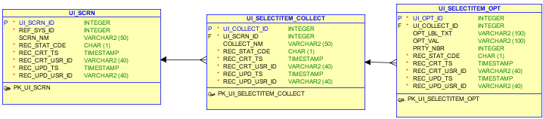

UI_SCREEN

Table: UI_SCRN
Column | Type | Required | Description
UI_SCRN_ID | INT | Y | Primary Key.
SCRN_NM | VARCHAR2 (50) | Y | (e.g., “submitNewRequestToVendor.jsp”)
REF_SYS_ID | INT | Y | References which application this screen belongs to
REC_STAT_CDE | CHAR(1) | Y | Standard Column – status code
REC_CRT_TS | TIMESTAMP | Y | Standard Column – created date
REC_CRT_USR_ID | VARCHAR2  (40) | Y | Standard Column – user who created the record
REC_UPD_TS | TIMESTAMP | Y | Standard Column – updated date
REC_UPD_USR_ID | VARCHAR2  (40) | Y | Standard Column – user who updated the record

UI_SELECTITEM_COLLECTION

Table: UI_SELECTITEM_COLLECT
Column | Type | Required | Description
UI_COLLECT_ID | INT | Y | Primary Key.
COLLECT_NM | VARCHAR2 (50) | Y | (e.g., “S2 Cancel Reason Codes Dropdown List”)
UI_SCRN_ID | INT | Y | Foreign Key: UI_SCREEN.Screen_Id.  References which screen this dropdown list belongs to
REC_STAT_CDE | CHAR(1) | Y | Standard Column – status code
REC_CRT_TS | TIMESTAMP | Y | Standard Column – created date
REC_CRT_USR_ID | VARCHAR2  (40) | Y | Standard Column – user who created the record
REC_UPD_TS | TIMESTAMP | Y | Standard Column – updated date
REC_UPD_USR_ID | VARCHAR2  (40) | Y | Standard Column – user who updated the record

UI_SELECTITEM_OPTION

Table: UI_SELECTITEM_OPT
Column | Type | Required | Description
UI_OPT_ID | INT | Y | Primary Key.
OPT_LBL_TXT | VARCHAR2 (100) | Y | The dropdown list item visible to the user  (e.g., “210 – Soft Cancel; Failed Renewal Authorization”)
OPT_VAL | VARCHAR2 (100) | Y | The value of the selected list item.  (e.g., “210”)
PRTY_NBR | INT | Y | Use to configure sort order in dropdown list  Default Value=0
UI_COLLECT_ID | INT | Y | Foreign Key: UI_SELECTITEM_COLLECTION.Collection_Id.  References which dropdown list this option belongs to
REC_STAT_CDE | CHAR(1) | Y | Standard Column – status code
REC_CRT_TS | TIMESTAMP | Y | Standard Column – created date
REC_CRT_USR_ID | VARCHAR2  (40) | Y | Standard Column – user who created the record
REC_UPD_TS | TIMESTAMP | Y | Standard Column – updated date
REC_UPD_USR_ID | VARCHAR2  (40) | Y | Standard Column – user who updated the record

Glossary

The following terms are defined here as pertains to their use within this document only.

Term | Description
Service Delivery Platform (SDP) | Best Buy enterprise integration system that encompasses applications for the processing, provisioning, and persistence of customer subscription information.
Operations UI  (OpsUI) | Business Operations UI for SDP.
Third Party Adapter (TPA) | Vendor provisioning component of SDP. This component holds all vendor transaction records.
Model View Controller (MVC) | Common design pattern for web applications defining division of labor amongst components
Java Server Faces (JSF) | The standard web app framework for the Java Enterprise Edition platform
Real Time Activation  (RTA) | Type of activation in Universal Basket project.

